SIMATS ENGINEERING
ASSESSMENT TOOL 2

COURSE NAME: COMPUTER NETWORKS
COURSE CODE: CSA0706

COURSE OUTCOME COVERED

CO4:
Design network topologies star, mesh, bus, and hybrid using networking devices, transmission media, and cabling standards
(BL2,BL6)

Assessment Tool Weightage: 30%

Annexure A

Industry Problem Solving Task

Code of Conduct:

I DAKSHIN.S(192511431)(Name / Reg No) certify that this submission is my original work and that I have adhered to the guidelines specified for this assessment.
I understand that any violation of academic integrity rules will result in disciplinary action.

Signature of the student: DAKSHIN.S

- A star topology is ideal for a 20-person startup because all devices connect to a central switch, making the network easy to manage and troubleshoot. At the core sits a Layer 2/Layer 3 managed switch (such as a Cisco Catalyst or Netgear ProSafe) with at least 24 ports to accommodate all workstations, printers, and VoIP phones with room to grow. Each device connects to the switch using Cat6 UTP cables, which support Gigabit speeds up to 100 meters — more than sufficient for any typical office floor plan. The switch uplinks to a router/firewall (such as a Cisco RV series or pfSense appliance) that handles internet access, DHCP, and network address translation. A Wi-Fi access point connected to the switch extends wireless coverage for laptops and mobile devices. The key advantage of this design is fault isolation: if one workstation's cable fails, only that single node goes offline, leaving all other 19 employees unaffected. Centralised cable management also simplifies future moves, adds, and changes.
ANSWER:
Network Topology for a 20-Person Startup
For a 20-person startup, star topology is the most suitable choice because it provides a simple, reliable, and easy-to-manage network structure. In a star topology, all computers and other network devices are connected to a central switch. This central device manages communication between the connected devices and allows the network administrator to easily monitor and troubleshoot network problems.
At the center of the network, a 24-port managed switch can be used. A 24-port switch is suitable because it can connect approximately 20 employees' computers along with other devices such as printers, VoIP phones, network storage devices, and wireless access points. It also provides some extra ports for future expansion. A managed switch is preferable because it provides better control, monitoring, VLAN configuration, and troubleshooting capabilities.
Each workstation can be connected to the switch using Cat6 UTP cables. Cat6 cables support high-speed Ethernet connections and can normally support Gigabit Ethernet over distances up to 100 meters, which is more than sufficient for a typical office environment. Using separate cables for each device also makes it easier to identify and replace a faulty connection.
The central switch can then be connected to a router or firewall. The router provides access to the Internet and can perform functions such as DHCP, NAT, and routing between different networks. The firewall provides security by controlling incoming and outgoing network traffic and protecting the company's internal network from unauthorized access.
A wireless access point (WAP) can also be connected to the switch to provide Wi-Fi connectivity. This allows employees to connect laptops, smartphones, tablets, and other wireless devices without requiring physical Ethernet cables. If the office is larger or has areas with weak Wi-Fi coverage, additional access points can be added.
One of the major advantages of star topology is fault isolation. If the cable or network interface of one employee's computer fails, only that particular device will lose network connectivity. The other employees can continue using the network normally. For example, if one workstation's Cat6 cable becomes damaged, the remaining 19 employees are not affected. However, the central switch is a critical component, so its failure can affect the entire network. Using a reliable managed switch or a backup switch can reduce this risk.
Another advantage is easy maintenance and future expansion. Since every device has an individual connection to the central switch, network administrators can easily identify faulty devices or cables. New computers, printers, phones, or access points can also be added by connecting them to available switch ports.
For a 20-person startup, star topology is an efficient, reliable, scalable, and cost-effective network design. It provides centralized management, easy troubleshooting, good performance, and simple future expansion. A suitable setup would consist of a 24-port managed switch, Cat6 UTP cables, a router/firewall, and one or more wireless access points. This design provides a strong foundation for the startup's current requirements while allowing the network to grow in the future.
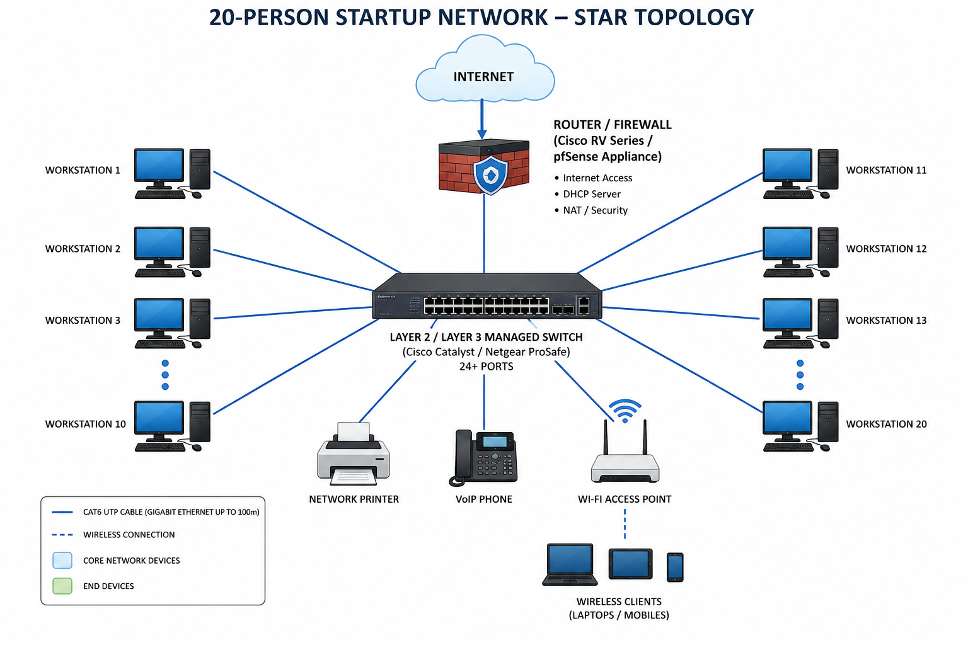

- A bank demands near-zero downtime, making a full or partial mesh topology the right choice. In a full mesh, every core network device — routers, core switches, and servers — connects directly to every other device, so no single link or node failure can bring down the network. For a bank, a partial mesh is typically deployed at the core layer (connecting all core switches and firewalls to each other) while the distribution and access layers use redundant uplinks to at least two core switches. Dual enterprise-grade routers (such as Cisco ASR or Juniper MX series) provide BGP-based redundant internet connectivity. All links between core devices use fiber optic cables — either single-mode for long distances between buildings or multi-mode OM4 within the data center — because fiber is immune to electromagnetic interference, supports very high bandwidth, and is essential for maintaining low-latency financial transactions. Redundant power supplies, UPS systems, and RAID storage arrays further complement the mesh design. The justification is straightforward: when a link fails in a mesh, traffic automatically reroutes through alternative paths in milliseconds using protocols like OSPF or BGP, satisfying regulatory requirements for uptime and data integrity.

ANSWER:
Network Topology for a Bank Requiring Near-Zero Downtime
For a banking network that requires near-zero downtime, a full or partial mesh topology is the most suitable choice because it provides high reliability, redundancy, and fault tolerance. Banking systems handle critical transactions such as fund transfers, ATM services, online banking, and payment processing. Therefore, the network must remain available even when a device, cable, or network connection fails.
In a full mesh topology, every major network device is directly connected to every other device. This can include core routers, core switches, firewalls, and critical servers. Because multiple communication paths are available, the failure of one link does not necessarily interrupt network communication. Traffic can be redirected through another available connection.
However, implementing a full mesh across an entire bank can be very expensive and complex. Therefore, a partial mesh topology is generally more practical. The core layer can have multiple connections between important switches, routers, and firewalls, while the distribution and access layers can use redundant uplinks to at least two core switches. This provides alternative paths while keeping the overall network manageable.
The bank can also use dual enterprise-grade routers to provide redundant Internet connectivity. Technologies such as BGP can be used to manage multiple Internet connections. If one Internet connection or router becomes unavailable, traffic can be redirected through the backup connection. This helps maintain continuous access to online banking and other external services.
For connections between important core devices, fiber-optic cables are highly suitable. Single-mode fiber can be used for long-distance connections between buildings, while multi-mode fiber such as OM4 can be used for shorter connections within a data center. Fiber provides high bandwidth, low latency, and resistance to electromagnetic interference, making it appropriate for high-speed banking networks.
Network redundancy should not be limited to cables and switches. The bank should also use redundant power supplies, UPS systems, backup generators, and reliable storage systems such as RAID. These additional components help ensure that hardware or power failures do not cause prolonged service interruptions.
Dynamic routing protocols such as OSPF or BGP can help the network automatically select an alternative path when a primary connection fails. This allows traffic to be rerouted without requiring manual intervention. As a result, the bank can maintain high network availability and reduce downtime during hardware or link failures.
The main advantage of mesh topology in a banking environment is its fault tolerance. If one network link fails, other available links can continue carrying the traffic. Similarly, if one core device becomes unavailable, redundant devices can continue providing network services. This reduces the possibility of a single point of failure.
A partial mesh topology with redundant core devices and connections is generally the best choice for a bank because it provides high availability, fault tolerance, scalability, and reliable communication. Combined with dual routers, redundant switches, fiber-optic connections, dynamic routing, backup power, and redundant storage, this design can support critical banking operations while minimizing downtime and maintaining reliable financial transactions.

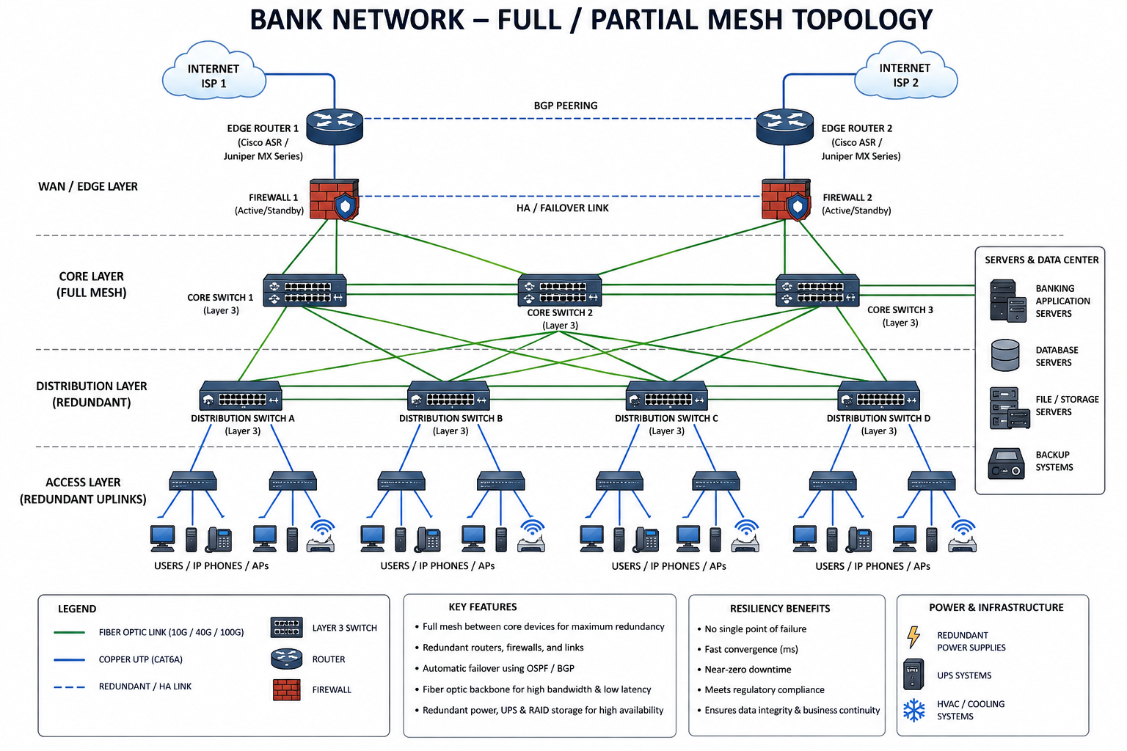

- For a small classroom lab with a tight budget, bus topology offers the lowest hardware cost because all computers share a single common communication line — the bus — eliminating the need for a central switch or hub. A single coaxial cable (RG-58, 50-ohm) or, in a modern variation, a single Cat5e/Cat6 cable daisy-chained through an inexpensive unmanaged hub runs along the length of the room. Each computer connects to the backbone using a T-connector and a BNC connector in a classic coaxial setup, with terminators (50-ohm) placed at both ends of the cable to absorb signals and prevent reflection. For a more contemporary low-cost implementation, a single inexpensive 8- or 16-port unmanaged switch replaces the terminators and uses Cat5e UTP patch cables to each workstation — achieving bus-like simplicity at minimal cost. The primary limitation is that the network is susceptible to collisions and a single cable break disrupts all connected machines, but for a supervised classroom environment with light usage (internet browsing, file sharing), this trade-off is entirely acceptable. No dedicated server is required; a teacher's PC can share resources using built-in Windows/Linux file sharing.
ANSWER:
Network Topology for a Small Classroom Lab with a Limited Budget
For a small classroom computer lab with a tight budget, a bus topology can be considered because it requires fewer networking components and has a simple structure. In a traditional bus topology, all computers share a single main communication cable called the backbone. This reduces the amount of cabling and hardware required, making it a low-cost option for a small number of computers.
In a classic bus network, a coaxial cable such as RG-58 can be used as the backbone. Each computer is connected to the backbone using appropriate connectors, such as BNC T-connectors. A 50-ohm terminator is placed at both ends of the backbone cable to prevent signal reflection and communication problems. Since all computers share the same cable, data travels along the backbone and is received by the appropriate destination computer.
The main advantage of this arrangement is its low hardware and installation cost. Unlike star topology, a traditional bus network does not require a central switch or hub for every connection. This makes it suitable for a small classroom where only a limited number of computers need to communicate. It also requires less cable, which can further reduce the overall installation cost.
However, traditional bus topology has several limitations. Since all computers share the same communication medium, network traffic and collisions can increase when several computers transmit data at the same time. As the number of computers increases, network performance may decrease. Another major disadvantage is that a failure in the main backbone cable can disrupt communication for all connected computers, making troubleshooting more difficult.
For a modern classroom, however, a traditional coaxial bus topology is rarely used. A more practical and inexpensive solution would be a small Ethernet star network using an unmanaged switch. For example, an 8-port or 16-port unmanaged switch can connect the classroom computers using Cat5e or Cat6 UTP cables. This provides a simple and affordable network while avoiding many of the reliability problems of a traditional bus topology.
The classroom does not necessarily require a dedicated server if the requirements are simple. A teacher's computer can share files, folders, printers, or other resources using the built-in Windows or Linux network-sharing features. Internet access can also be provided through a basic router connected to the network.
Therefore, if the question specifically requires a traditional low-cost topology, bus topology provides a simple and inexpensive solution for a small classroom. However, if reliability and easier maintenance are also important, a small star topology with an inexpensive unmanaged switch would be a better modern choice.
Bus topology offers low hardware cost, simple installation, and minimal equipment, making it suitable for a small classroom with light network usage. However, it has limitations such as collisions, difficult fault detection, and the possibility that a backbone failure can affect the entire network. For a modern classroom, a small star network using an inexpensive Ethernet switch is generally more practical, reliable, and easier to maintain.
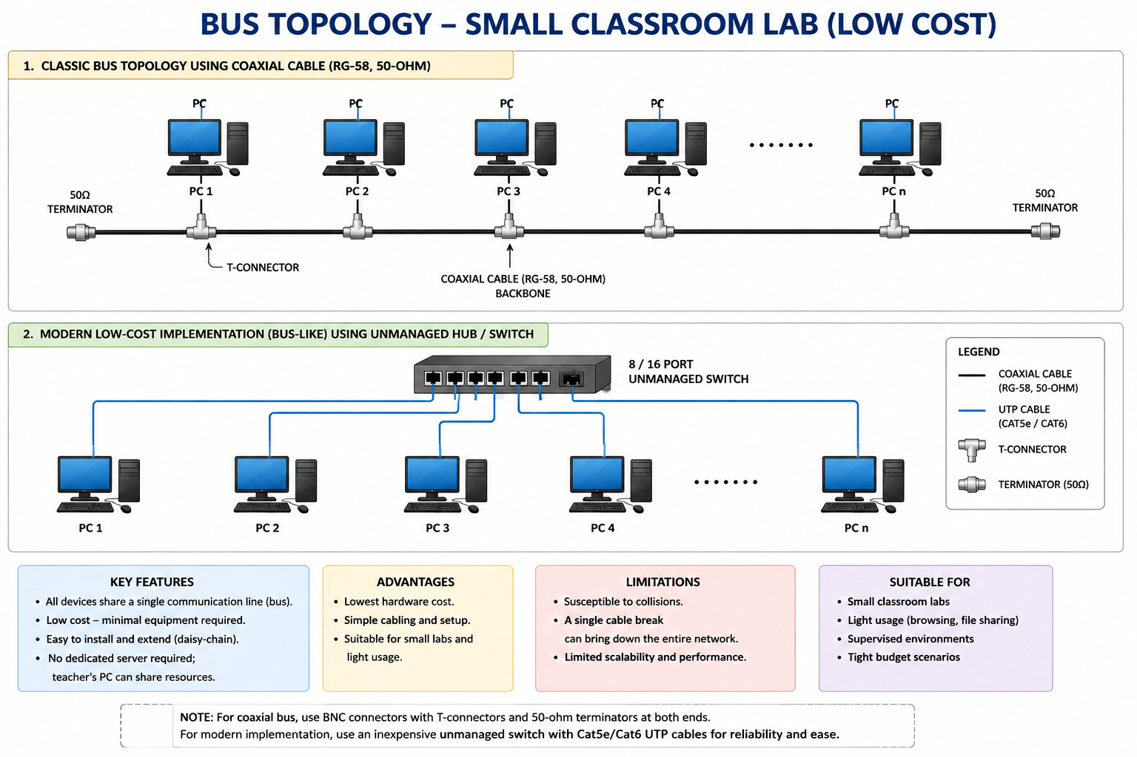

- A large university campus serves thousands of users across multiple buildings — lecture halls, labs, libraries, dormitories, and administration — making a single topology inadequate. A hybrid topology combines the best elements of multiple designs: a fiber-based ring or mesh at the campus backbone level for redundancy, a star topology within each building for manageability, and bus or tree structures within individual labs for cost-efficiency. At the campus core, high-speed fiber optic cables (single-mode, 10 Gbps or 40 Gbps) interconnect core routers and multilayer switches using a ring or partial mesh arrangement, ensuring that no single link failure isolates an entire building. Each building has its own distribution switch connected to the campus core via dual fiber uplinks. Within each building, a traditional star topology branches from the distribution switch to floor-level access switches, which then connect individual devices via Cat6 cables. This hierarchical three-layer model — core, distribution, and access — is the industry standard for enterprise and campus networks because adding a new building simply means installing a new distribution switch and running fiber to the core, with no disruption to existing infrastructure. Wireless access points throughout the campus connect via PoE (Power over Ethernet) to access switches, eliminating the need for separate power cabling. The hybrid design thus delivers redundancy at the backbone, simplicity at the building level, and scalability campus-wide.

ANSWER:
Hybrid Topology for a Large University Campus
A hybrid topology is the most suitable network design for a large university campus because the campus contains thousands of users distributed across different buildings such as lecture halls, computer laboratories, libraries, hostels, administrative offices, and research centers. Since the requirements of each area are different, using a single topology for the entire campus would not be efficient. A hybrid topology combines the advantages of different topologies to provide high performance, reliability, flexibility, and scalability.
At the campus backbone or core level, a fiber-optic ring or partial mesh topology can be used to connect the major core routers and multilayer switches. High-speed fiber connections, such as 10 Gbps or 40 Gbps, can provide fast communication between different buildings. The ring or mesh arrangement provides multiple paths for data transmission. Therefore, if one fiber link fails, traffic can be redirected through another available path, reducing network downtime.
Each university building can have its own distribution switch connected to the campus core using dual fiber-optic uplinks. Having two connections provides redundancy. If one fiber link fails, the second link can continue carrying network traffic. This is especially important for buildings such as laboratories, libraries, and administration offices where continuous network access is required.
Inside each building, a star topology can be used. The distribution switch connects to floor-level access switches, and these access switches connect individual computers, printers, IP phones, and other devices. Cat6 Ethernet cables can be used for connecting devices within floors. Star topology makes the building network easier to install, manage, troubleshoot, and expand.
For individual computer laboratories or small sections, tree or bus-like structures may be used where appropriate to reduce installation costs. However, in modern campus networks, switched Ethernet star/tree designs are generally preferred because they provide better performance and reliability than traditional shared bus networks.
The complete network can follow a three-layer hierarchical architecture: Core, Distribution, and Access. The core layer provides high-speed communication between buildings, the distribution layer manages routing, security, and connectivity for individual buildings, and the access layer connects end-user devices. This hierarchical structure makes the network easier to manage and allows administrators to isolate problems to specific sections.
Wireless connectivity can also be provided throughout the campus using Wi-Fi access points. These access points can be connected to access switches using Power over Ethernet (PoE). PoE allows both network data and electrical power to travel through the same Ethernet cable, reducing the need for separate power connections at every access point.
One of the major advantages of this hybrid design is scalability. If the university constructs a new building, a new distribution switch can be installed and connected to the existing campus core using fiber-optic links. There is no need to redesign the entire network. Similarly, additional access switches and wireless access points can be added when the number of students and staff increases.
The hybrid topology also provides fault tolerance and reliability. The fiber-based ring or partial mesh at the core provides alternative communication paths, while dual uplinks provide backup connections for buildings. At the building level, star topology makes it easier to identify and replace faulty cables or devices without affecting the entire campus network.
A hybrid topology is an excellent choice for a large university campus because it combines redundancy at the backbone, easy management within buildings, cost efficiency in smaller sections, and scalability across the campus. By combining fiber-based ring or mesh connectivity with star-based building networks and a hierarchical core-distribution-access architecture, the university can provide a fast, reliable, secure, and expandable network capable of supporting thousands of students, faculty, and staff.
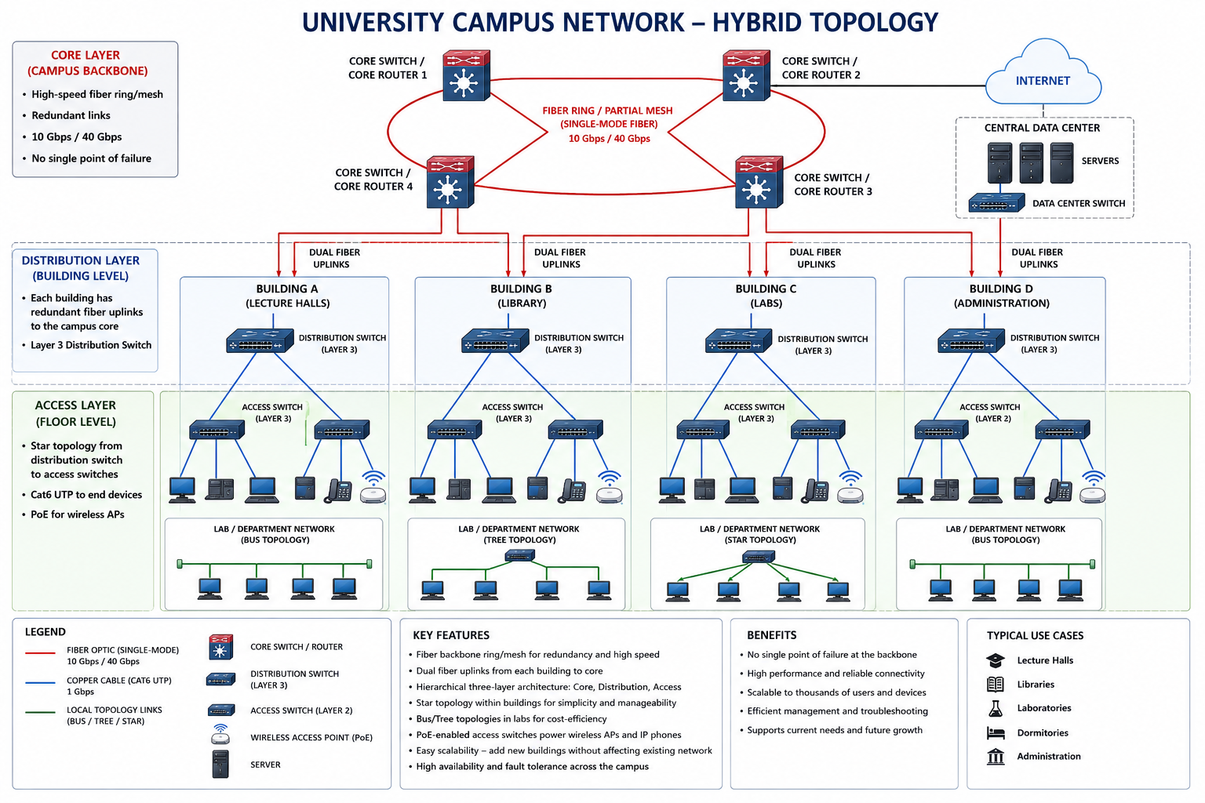

- Designing a network for a company with multiple departments involves creating a structured and scalable architecture using switches and routers to ensure efficient communication and security. Each department (such as HR, Finance, Sales, and IT) is connected through dedicated Layer 2 switches that form the access layer, allowing devices like computers and printers to communicate within the same department. These switches are then connected to a central Layer 3 switch or router, which acts as the core layer and enables communication between different departments through inter-VLAN routing. Virtual LANs (VLANs) are configured to logically separate each department’s network, improving security and reducing broadcast traffic. A router is also used to connect the internal network to external networks such as the internet, often with firewall functionality for security. Redundant links and backup paths can be included to ensure reliability, while proper IP addressing and subnetting are applied for efficient network management. This hierarchical design improves performance, enhances security, and allows easy expansion as the company grows.

ANSWER:
Network Design for a Company with Multiple Departments
Designing a network for a company with multiple departments requires a structured, secure, scalable, and reliable network architecture. Departments such as HR, Finance, Sales, and IT need to communicate with each other when required, while sensitive information should be protected from unauthorized access. A hierarchical network design using Layer 2 switches, Layer 3 switches, routers, and VLANs is suitable for this type of organization.
Each department can be connected to a dedicated Layer 2 switch at the access layer. Computers, printers, IP phones, and other devices within a department are connected to these switches. For example, HR employees can connect to the HR switch, while Finance employees connect to the Finance switch. This provides efficient communication between devices within the same department.
VLANs (Virtual Local Area Networks) can be configured to logically separate the departments. For example, VLAN 10 can be assigned to HR, VLAN 20 to Finance, VLAN 30 to Sales, and VLAN 40 to IT. Even though all departments may use the same physical network infrastructure, VLANs keep their network traffic logically separated. This improves security, reduces unnecessary broadcast traffic, and provides better network management.
The departmental switches can then be connected to a central Layer 3 switch. The Layer 3 switch performs inter-VLAN routing, allowing devices from different VLANs to communicate when permitted. For example, an authorized Finance computer can communicate with an HR server, while unnecessary communication between departments can be restricted using access control rules.
A router or firewall can be connected to the Layer 3 switch to provide Internet connectivity. The firewall can inspect network traffic and block unauthorized connections. It can also provide security features such as access control, network address translation, and protection against unwanted external traffic.
Proper IP addressing and subnetting should also be implemented for each department. Each VLAN can have its own IP subnet. For example, HR, Finance, Sales, and IT can be assigned separate network ranges. This makes it easier for administrators to identify devices, control traffic, troubleshoot problems, and manage the network efficiently.
For better reliability, the company can use redundant links and backup network devices. Important switches can have multiple connections, and critical network equipment can have backup power supplies. If one network link fails, another link can be used to maintain communication. This reduces downtime and improves network availability.
The hierarchical structure can be organized into three main layers: Access Layer, Distribution/Core Layer, and Network/Internet Layer. The access layer connects end-user devices, the Layer 3 distribution or core layer manages routing and communication between VLANs, and the router/firewall provides secure connectivity to external networks.
This design also provides easy scalability. When the company adds new employees or departments, additional switches, VLANs, and IP subnets can be introduced without redesigning the entire network. Network administrators can also apply different security policies to different departments according to their requirements.
A hierarchical network using Layer 2 switches, VLANs, a Layer 3 switch, routers, and firewalls is an effective solution for a company with multiple departments. It provides efficient communication, improved security, reduced broadcast traffic, easier management, high reliability, and future scalability. Therefore, this design is suitable for organizations that require a secure and well-organized network infrastructure.

